

ENGINEERING CLINICS
REVIEW-3
Ec_ID: 241139
GUIDED BY DR.SATYENDRA SINGH CHAUHAN

23BCE8133 – AKUNURI JAYADITHYA
23BCE9528 – SAMPENGALA VISWAS
23BCE9527 – GANJIMALA AKHILA
23BCE8238 – BATTU TANMAI KIRAN
23BCE9548 – KUMBHA SAI LAKSHMI TEJASWINI
23BCE9531 – SRAVYA DOPPALAPUDI

Arduino Earthquake Detector

Introduction of the project
Among the most formidable and concerning natural phenomena, earthquakes stand out due to their sudden and potentially devastating impact on our environment and societies. Earthquakes are not mere tremors; they are powerful geological events caused by the sudden release of energy within the Earth’s crust.

Earthquakes lead to critical consequences, causing Catastrophic damages. Early identification of seismic activity is essential to minimise destruction.

This Arduino Earthquake detector is a phenomenal solution which can be used in high rate of earthquake regions all over the world. It provides a forward-looking strategy for earthquake preparedness by improving safety, minimizing damage, and potentially preserving lives.

Applicable in various environments such as homes, schools, research facilities, or integrated into a comprehensive community alert system, the Arduino Earthquake Detector Alarm with Seismic Graph serves as a highly effective tool for detecting and responding to seismic events

Applications
Early Alert
Provides advance notifications of seismic activity, giving people critical seconds to take precautionary actions like seeking shelter, turning off gas lines, or evacuating buildings, which can help save lives and reduce injuries.

Improved Safety Measures
By informing individuals and communities about approaching earthquakes, the system increases safety during seismic events, lowering the risk of harm and panic.

Protection of Essential Infrastructure
This technology can be integrated into key infrastructure such as power plants, hospitals, schools, public buildings, and data centres to safeguard equipment and ensure continued functionality during earthquakes.

Strengthening Community Preparedness
Deploying these systems in earthquake-vulnerable regions boosts community preparedness by ensuring residents are equipped to handle seismic events.

Objective
The goal of creating an Arduino Earthquake Detector Alarm with a Seismic graph using an accelerometer is to offer an affordable and user-friendly solution for detecting and warning about seismic activity and earthquakes.

Working Explanation
The working explanation of Arduino Earthquake Detector Alarm with Seismic Graph using Accelerometer.
1.Data Acquisition
The system continuously collects data from an accelerometer sensor, which measures acceleration in three axes: X, Y, and Z. This sensor generates analog voltage signals in response to motion and vibrations.
2.Data Processing
The Arduino processes the digital accelerometer data to calculate the overall magnitude of acceleration, which is often referred to as the "g-force." This magnitude represents the total acceleration experienced by the sensor and is used to assess the level of seismic activity.
3.Threshold Comparison
Customizable thresholds are set to determine what level of acceleration is considered significant enough to indicate seismic activity. For example, a threshold might be set at 1 g (equal to the force of gravity) or a higher value depending on the system's sensitivity requirements.
4.Real-time Monitoring
The Arduino continuously monitors the calculated magnitude of acceleration in real-time. It compares this value to the predefined threshold(s) to determine if seismic activity is occurring.
5.Alert Generation
When the magnitude of acceleration exceeds the set threshold(s), the Arduino triggers the earthquake detection alarm system. This alert can take various forms:
Audible Alert: An alarm or buzzer sounds to notify people nearby.
Visual Alert: Seismic data is displayed on an attached screen (e.g., OLED, LCD, or LED) as a real-time graph, showing the intensity and duration of shaking.

Circuit Diagram
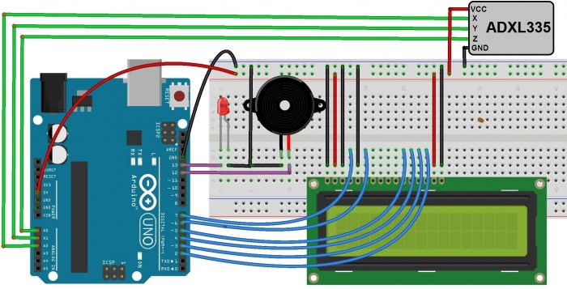
Circuit Diagram & Connections

Required components
1.Arduino Uno Board
2.Accelerometer sensor (ADXL335)
3.Breadboard
4.Jumper wires
5.Buzzer
6. 16*2 LCD Display
7. LED
8.Power source (USB/Battery)
9.Resistors
10.Capacitors
11.Push buttons

Budget Estimation
Arduino Uno Board 650/-
Accelerometer sensor (ADXL335) 600/-
Jumper wires 100/-
Buzzer 50/-
16*2 LCD Display 300/-
LED 30/-
The approximate budget for building an Arduino Earthquake Detector Alarm with a Seismic Graph using an accelerometer is estimated to be between rupees 3000 to 3500.

Plan of Action
1.Defining Project Scope and Goals (1st Week)
Establish the project's title and objectives. Identify its real-life applications and importance.

2.Research and Component Selection (1st Week)
Research suitable accelerometer sensors, displays, and other components that match the project's requirements and budget. Procure all necessary materials.

3.Creating a Circuit Diagram (2nd Week)
Design the circuit diagram to outline how all components will be connected to the Arduino board.

4.Setting the Workspace (2nd Week)
Prepare a safe, well-lit workspace with all necessary tools and safety precautions.

5.Assembling the Hardware (3rd Week)
Connect all components based on the circuit diagram, ensuring accurate wiring and connections.

6.Writing Arduino Code (4th Week)
Develop the Arduino program to read accelerometer data, trigger alarms, and display seismic activity on the screen.

7.Sensor Calibration (4th Week)
Calibrate the accelerometer for accurate seismic readings and set threshold values for earthquake detection.

8.Testing and Debugging (4th Week)
Test the setup under various conditions to verify its functionality. Debug and improve the code as needed.

9.Alarm System Integration (5th Week)
Integrate the alarm system to activate during detected seismic activity.

10.Power Supply and Management (5th Week)
Ensure a stable and reliable power supply for the system.

11.Safety Measures (5th Week)
Implement safety precautions to avoid false alarms or system damage due to non-seismic vibrations.

12.Deployment (6th Week)
Install the earthquake detector in a location suitable for monitoring seismic activity.

13.Maintenance and Monitoring (6th Week)
Regularly monitor and maintain the system to ensure accuracy and continued operation.

14.Final Testing (7th Week)
Conduct a comprehensive test to verify that the Arduino earthquake detector and alarm system work as expected.
Principle and working of the Components
Arduino Uno
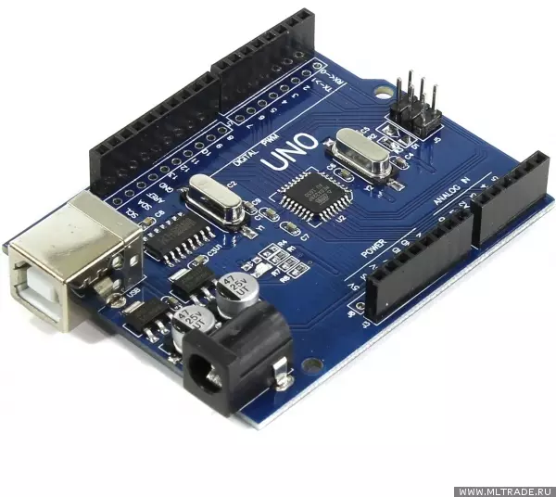
An Arduino Earthquake Detector, built with an Arduino Uno, usually functions by utilizing a seismic sensor (like an accelerometer or vibration sensor) to sense vibrations triggered by earthquakes. Here's an overview of its operation.
Sensor Input: The seismic sensor is wired to one of the analog or digital input pins on the Arduino Uno. It is capable of detecting vibrations or accelerations in its surroundings.
Data Processing: The Arduino Uno receives the analog or digital signals from the sensor and, if needed, converts the analog signals into digital data using its analog-to-digital converter (ADC). It then processes this data to identify significant changes in acceleration, which may signal seismic activity.
Threshold Detection: The Arduino Uno compares the sensor data against a predefined threshold value. If the sensor readings surpass this threshold, it interprets the event as seismic activity.
Alert System: When the Arduino detects seismic activity that exceeds the threshold, it can activate an alert system. This might include sounding an alarm, sending notifications via email or SMS, or displaying a warning message on an LCD screen.
Power Supply: The Arduino Uno needs a power supply, which can be delivered via USB or an external power source, ensuring the earthquake detection system operates continuously.
Programming: The logic for threshold detection and alert mechanisms is programmed into the Arduino Uno using the Arduino IDE. This involves writing code that tells the Arduino how to process the sensor data and respond to earthquake-like vibrations.

Accelerometer sensor (ADXL335)

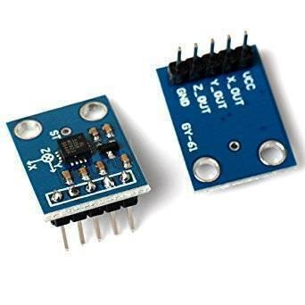

The ADXL335 sensor has 6 pins and features an integrated chip on the front of the board, with the pins soldered on the back.

- VCC: Provides the power supply.
- X-out: Outputs the acceleration measured along the x-axis.
- Y-out: Outputs the acceleration measured along the y-axis.
- Z-out: Outputs the acceleration measured along the z-axis.
- GND: Connects to the ground.
- ST: The self-test pin, located above the integrated chip, allows you to verify the functionality of the accelerometer in the final model.

The ADXL335 is a compact, low-power 3-axis accelerometer capable of detecting acceleration along the X, Y, and Z axes, making it useful for sensing changes in motion and acceleration.

Breadboard
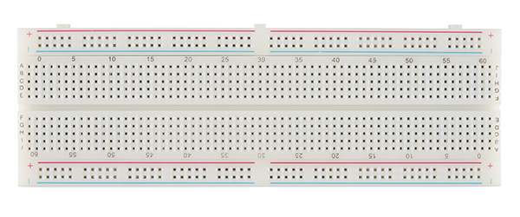

A breadboard, also known as a plug block, is used for constructing temporary circuits. It is valuable for designers because it allows easy removal and replacement of components. This makes it ideal for anyone who wants to build a circuit to demonstrate its function and then reuse the components in a different circuit.
Jumper wires
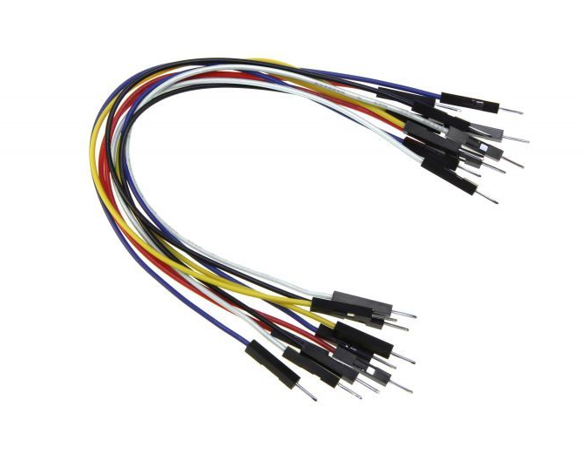

A jumper wire is an electrical wire that connects distant electric circuits, commonly used in printed circuit boards. By attaching a jumper wire to the circuit, it can create a short circuit, effectively bridging connections. In this project, we utilized approximately 15 male-to-male jumper wires.

Buzzers

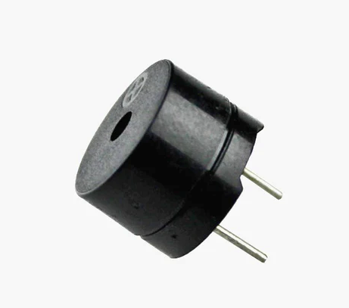

A buzzer or beeper is an audio signalling device that can be mechanical, electromechanical, or piezoelectric (often referred to as piezo). Common applications for buzzers and beepers include alarm systems, timers, train signals, and confirming user inputs like mouse clicks or keystrokes.

16x2 LCD display

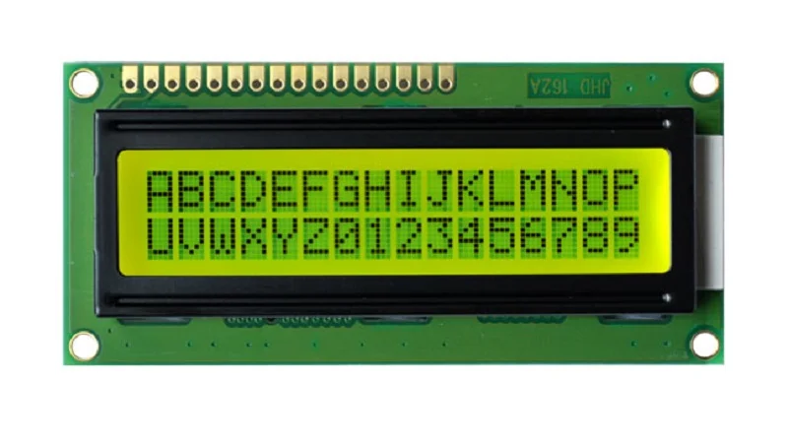

The 16x2 LCD display is a basic module widely used in various devices and circuits. It can display 16 characters per line across 2 lines, with each character represented in a 5x7 pixel matrix.

The 16x2 LCD is connected to the Arduino Uno using jumper wires. The display has multiple pins for data and control, which are linked to specific digital pins on the Arduino. It also requires power connections.

When seismic activity above the threshold is detected, the Arduino sends relevant messages or data to the LCD display. This information might include alerts like "Earthquake Detected!" or specific data such as the intensity or magnitude of the earthquake.
LED
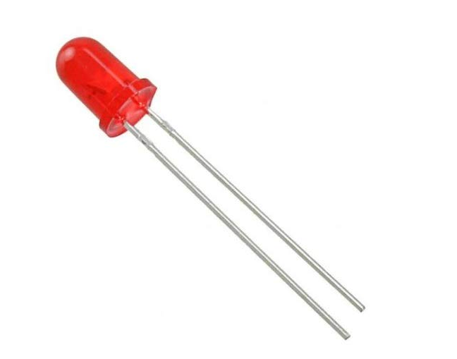
In simple terms, a light-emitting diode (LED) is a semiconductor device that emits light when an electric current flows through it. The light is generated when the particles carrying the current combine within the semiconductor material.

Working explanation of the project

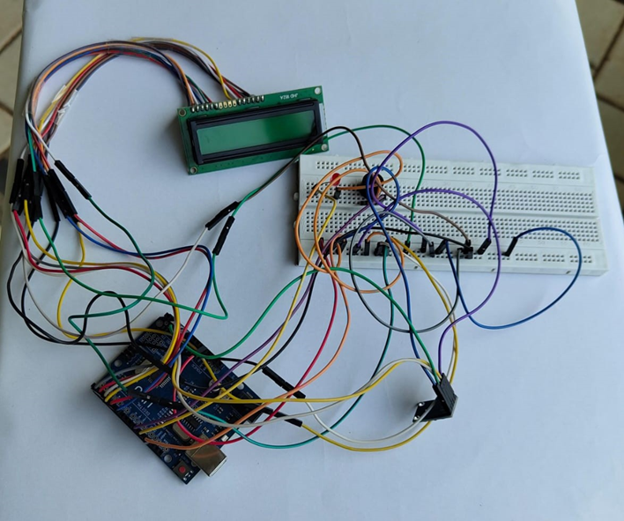
Arduino Earthquake Detector
The accelerometer sensor is positioned on a stable surface to effectively detect ground vibrations. When an earthquake or significant ground movement occurs, the sensor generates a signal that corresponds to the detected vibrations. This signal is sent to the Arduino Uno board, which can read it using its analog or digital pins.

In the Arduino code, a threshold value is established, determining the minimum vibration level required to trigger the system. If the sensor's signal exceeds this threshold, it indicates that an earthquake is happening. When the Arduino detects vibrations above this threshold, it activates the alert system, which can include turning on LEDs, sounding a buzzer, or displaying a message on an LCD screen.

Arduino Uno Source Code:
We developed code in the Arduino programming language. Arduino programming is based on the C and C++ languages, so the syntax and structure of Arduino sketches are similar to C/C++ programming. Arduino provides a simplified interface and set of libraries to make it easier for beginners to work with microcontrollers and sensors.

Code:
#include <LiquidCrystal.h> // lcd Header
LiquidCrystal lcd(7, 6, 5, 4, 3, 2); // pins for LCD Connection

#define buzzer 12 // buzzer pin
#define led 13 //led pin

#define x A0 // x_out pin of Accelerometer
#define y A1 // y_out pin of Accelerometer
#define z A2 // z_out pin of Accelerometer

/*variables*/ int xsample = 0; int ysample = 0; int zsample = 0; long start; int buz = 0;
bool earthquakeDetected = false; // Flag to track earthquake detection

/*Macros*/
#define samples 10
#define maxVal 50 // max change limit
#define minVal -50// min change limit

void setup()
{
lcd.begin(16, 2); //initializing lcd Serial.begin(9600); // initializing serial delay(1000); lcd.print("EarthQuake "); lcd.setCursor(0, 1); lcd.print("Detector "); delay(2000); lcd.clear();
lcd.print("Calibrating....."); lcd.setCursor(0, 1); lcd.print("Please wait...");
pinMode(buzzer, OUTPUT); pinMode(led, OUTPUT); buz = 0;
digitalWrite(buzzer, buz); digitalWrite(led, buz);
for (int i = 0; i < samples; i++) // taking samples for calibration
{
xsample += analogRead(x); ysample += analogRead(y); zsample += analogRead(z);
}

xsample /= samples; // taking avg for x ysample /= samples; // taking avg for y zsample /= samples; // taking avg for z

delay(3000); lcd.clear(); lcd.print("Calibrated"); delay(1000); lcd.clear(); lcd.print("Device Ready"); delay(1000); lcd.clear(); lcd.print(" X Y Z ");
}

void loop()
{
int value1 = analogRead(x); // reading x out int value2 = analogRead(y); //reading y out int value3 = analogRead(z); //reading z out

int xValue = xsample - value1; // finding change in x int yValue = ysample - value2; // finding change in y int zValue = zsample - value3; // finding change in z

/*displying change in x, y and z axis values over lcd*/ lcd.setCursor(0, 1); lcd.print(xValue); lcd.setCursor(6, 1); lcd.print(yValue); lcd.setCursor(12, 1); lcd.print(zValue); delay(100);

/* comparing change with predefined limits*/
if (xValue < minVal || xValue > maxVal || yValue < minVal || yValue > maxVal || zValue < minVal || zValue > maxVal)
{
if (buz == 0)
{
start = millis(); // timer start
buz = 1; // buzzer / led flag activated earthquakeDetected = true; // Earthquake detected
}
}
else if (buz == 1 && earthquakeDetected) // buzzer flag activated then alerting earthquake
{
lcd.setCursor(0, 0); lcd.print("Earthquake Alert "); digitalWrite(buzzer, HIGH); // Turn on the buzzer buz = 2; // Set the flag to prevent repeated buzzing
}
else
{
lcd.clear(); lcd.print(" X Y Z ");
}

if (buz == 2)
{
// Stop the buzzer after buzzing once if (millis() >= start + 3000) // Buzz for 5 seconds
{
digitalWrite(buzzer, LOW); // Turn off the buzzer buz = 0; // Reset the buzzer flag
earthquakeDetected = false; // Reset the earthquake detection flag
}
}

digitalWrite(led, buz); // led on and off command

/*sending values to processing for plot over the graph*/
Serial.print("x=");
Serial.println(xValue);
Serial.print("y=");
Serial.println(yValue);
Serial.print("z=");
Serial.println(zValue);
Serial.println(" $");
}

Processing Code:
The Processing code facilitates communication with an Arduino Earthquake Detector by establishing a serial connection and continuously reading and parsing incoming data that includes X, Y, and Z values. It dynamically scales and maps these values to fit within the graphical window dimensions, producing a scrolling graph that represents seismic activity in real-time. The graph, with distinct colors for X, Y, and Z axes, scrolls horizontally as new data arrives, and the yaxis displays corresponding values. Additional features include labeled axis values, degree markings, and a visual representation of earthquake intensity, providing a comprehensive and interactive visualization of the detector's output.

Code:
import processing.serial.*;
PFont f6,f8,f12,f10;
PFont f24;
Serial myPort; // The serial port
int xPos = 0; // horizontal position of the graph
float y1=0; float y2=0; float y3=0;

void setup ()
{
// set the window size: and Font size f6 = createFont("Arial",6,true); f8 = createFont("Arial",8,true); f10 = createFont("Arial",10,true); f12 = createFont("Arial",12,true); f24 = createFont("Arial",24,true); size(1200, 700);

// List all the available serial ports println(Serial.list()); myPort = new Serial(this, "COM6", 9600); println(myPort); myPort.bufferUntil('\n'); background(80);
}

void draw ()
{ serial ();
}

void serial()
{
String inString = myPort.readStringUntil('$'); // reading incomming date from serial if (inString != null)
{
// extracting all required values of all three axis: int l1=inString.indexOf("x=")+2; String temp1=inString.substring(l1,l1+3); l1=inString.indexOf("y=")+2;
String temp2=inString.substring(l1,l1+3); l1=inString.indexOf("z=")+2;
String temp3=inString.substring(l1,l1+3);

//mapping x, y and z value with graph dimensions float inByte1 = float(temp1+(char)9); inByte1 = map(inByte1, -80,80, 0, height-80); float inByte2 = float(temp2+(char)9); inByte2 = map(inByte2,-80,80, 0, height-80); float inByte3 = float(temp3+(char)9); inByte3 = map(inByte3,-80,80, 0, height-80); float x=map(xPos,0,1120,40,width-40);

//ploting graph window, unit strokeWeight(2);
stroke(175); Line(0,0,0,100); textFont(f24); fill(0,00,255);
textAlign(RIGHT);
xmargin("EarthQuake Graph (SESMIOGRAPH)",200,100);

fill(100);
strokeWeight(100); line(1050,80,1200,80);

strokeWeight(1); textAlign(RIGHT);
fill(0,0,255);
String temp="X:"+temp1;
Text(temp,100,95);

fill(0,255,0);
temp="Y:"+temp2;
Text(temp,100,92);

fill(255,0,0);;
temp="Z:"+temp3;
Text(temp,100,89);

//ploting x y and z values over graph strokeWeight(2); int shift=40;

stroke(0,0,255); if(y1 == 0) y1=height-inByte1-shift; line(x, y1, x+2, height-inByte1-shift) ; y1=height-inByte1-shift;

stroke(0,255,0); if(y2 == 0) y2=height-inByte2-shift; line(x, y2, x+2, height-inByte2-shift) ; y2=height-inByte2-shift;

stroke(255,0,0); if(y2 == 0) y3=height-inByte3-shift; line(x, y3, x+2, height-inByte3-shift) ; y3=height-inByte3-shift;

xPos+=1;

if (x >= width-30) // go back to begining
{
xPos = 0; background(80);
}
}
}

void Line(int x1, int y1, int x2, int y2)
{
float xx1=map(x1,0,100,40,width-40); float xx2=map(x2,0,100,40,width-40); float yy1=map(y1,0,100,height-40,40); float yy2=map(y2,0,100,height-40,40);

line(xx1,yy1,xx2,yy2); xx2=map(100,0,100,40,width-40); yy2=map(0,0,100,height-40,40); line(xx1,yy1,xx2,yy2);

strokeWeight(1); for(int i=1;i<21;i++)
{
yy2=map(i*10,0,200,height-40,40); yy1=yy2; line(xx1,yy1,xx2,yy2);
}
yy2=map(100,0,100,height-40,40); yy1=map(0,0,100,height-40,40); for(int i=1;i<41;i++)
{
xx1=map(i*5,0,200,40,width-40); xx2=map(i*5,0,200,40,width-40); line(xx1,yy1,xx2,yy2);
}

textAlign(RIGHT); // 100 degree
// result+=yy1;
fill(255);
strokeWeight(1); textFont(f12); for(int i=-10;i<11;i++)
{
String result=""; result+=5*i; ymargin(result, x1,y1); y1+=5;
}

x1=0; y1=0; strokeWeight(1); textFont(f10); for(int i=0;i<41;i++) {
String result=""; result+=28*3*i; xmargin(result, x1,y1); x1+=5;
}

textAlign(RIGHT);

textAlign(RIGHT);
}

void ymargin(String value, int x1, int y1)
{

float xx1=map(x1,0,100,40,width-40); float yy1=map(y1,0,100,height-40,40); text(value,xx1-5,yy1+5);
}

void xmargin(String value, int x1, int y1)
{

float xx1=map(x1,0,200,40,width-40); float yy1=map(y1,0,100,height-25,25); text(value,xx1+7,yy1);
}

void Text(String value, int x1, int y1)
{

float xx1=map(x1,0,100,40,width-40); float yy1=map(y1,0,100,height-25,25); text(value,xx1,yy1);

Technical Progress
We made significant technical advancements in various aspects of the project. Here’s a summary of the progress achieved during this phase:

- Accelerometer Integration: Successfully integrated the accelerometer into the system, ensuring proper connections and communication with the Arduino board.

- Optimized Code Development: Developing an optimized code for processing sensor data, incorporating a dynamic threshold setting mechanism to adapt to varying environmental conditions.

Throughout this phase, the team demonstrated notable technical progress by effectively addressing complex challenges, refining algorithms, optimizing hardware, and ensuring the system's reliability and accuracy. These advancements have laid a solid foundation for the final stages of the project, showcasing the team's technical proficiency and collaborative problem-solving skills.

Problem Analysis
We performed a comprehensive problem analysis to identify the challenges and issues encountered during the development process.

- Threshold Value Optimization: We faced difficulties in establishing an optimal threshold value that effectively differentiates between normal vibrations and actual earthquake events.

- Component Integration Challenges: We encountered challenges while integrating various components, such as the accelerometer sensors and the Arduino Uno board.

Through this problem analysis, we gained valuable insights into the challenges faced throughout the project. These insights guided our efforts to find effective solutions and optimize the system.

Team Work
For the Arduino Earthquake Detector project, we divided tasks among team members based on their expertise and interests to facilitate collaboration. The project was split into two main teams:

Hardware Team: This team focused on connecting components and managing the power supply.

Software Team: This team worked on developing the Arduino code.

By distributing tasks and encouraging effective communication and collaboration, we successfully developed a comprehensive and functional Arduino Earthquake Detector, leveraging each member's expertise to achieve our goals.

